**BIOMASS BRIQUETTING:**

Direct burning of agro residues in domestic and industrial applications is inefficient and associated with wide scale air pollution. In order to achieve more efficient usage of agro residues, it is essential to densify them to compact pieces of definite shape. Briquetting is one

of the several compaction technologies in the category of densification. The process of briquetting consists of applying pressure to a mass of particles with or without a binder and converting it into a compact product of high bulk density, low moisture content, uniform size and shape and good burning characteristics. Briquettes can be produced with the density of 1.2 to 1.4 g/cm3 from loose agro residues with a bulk density of 0.1 to 0.2 g/cm3.

**Raw materials for briquetting:**

Almost all agro residues can be briquetted. Agro residues such as saw dust, rice husk, groundnut shell, soybean stalks, cotton stalks, sugar cane bagasse, wood chips are the commonly used raw materials for briquetting in India. All these residues can be briquetted individually and in combination with or without using binders. The factors that mainly influence on the selection of raw materials are moisture content, ash content, flow characteristics, particle size and availability in the locality. Moisture content in the range of 10-15% is preferred because high moisture content will pose problems in grinding and more energy is required for drying.

**Briquetting Process:**

The series of steps involved in the briquetting process are

1. Collection of raw materials: In general, any material that will burn, but is not in a convenient shape, size or form to be readily usable as fuel is a good candidate for briquetting.



2. Preparation of raw materials: The preparation of raw materials includes drying, size reduction, mixing of raw materials in correct proportion, mixing of raw materials with binder etc.

DRYING: The raw materials are available in higher moisture contents than what required for briquetting. Drying can be done in open air (sun), in solar driers, with a heater or with hot air.

SIZE REDUCTION: The raw material is first reduced in size by shredding, chopping, crushing, breaking, grinding, cutting etc. until it reaches a suitably small and uniform size (1 to 10 mm).

RAW MATERIAL MIXING:It is desirable to make briquettes of more than one raw material. Mixing will be done inproper proportion in such a way that the product should have good compaction

3. Compaction: Compaction process takes place inside the briquetting machine. The process depends on the briquetting technology adopted.

**Briquetting Technologies:**

Briquetting technologies used in the briquetting of the agro residues are divided into three categories. They are:

1. High pressure or high compaction technology: In high pressure briquetting machines, the pressure reaches the value of 100 MPa. This type is suitable for the residues of high lignin content. At this high pressure the temperature rises to about 200 - 250o C, which is sufficient to fuse the lignin content of the residue, which acts as a binder and so, no need of any additional binding material.
2. Medium pressure technology: In medium pressure type of machines, the pressure developed will be in the range of 5 MPa and 100MPa which results in lower heat generation. This type of machines requires additional heating to melt the lignin content of the agro residues which eliminates the use of an additional binder material.
3. Low pressure technology: The third type of machine called the low pressure machines works at a pressure less than 5 MPa and room temperature. This type of machines requires addition of binding materials due to the lack of the lignin material.



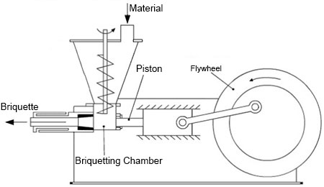

4. Cooling and Storage: Briquettes extruding out of the machines are hot with temperatures exceeding 100oC. They have to be cooled and stored in dry place.

**Advantages of agro residual briquettes:**

1. End product is easy to transport and store
2. The fuel produced is uniform in size and quality
3. Helps solve the problem of residue disposal
4. Helps to reduce deforestation by providing a substitute for fuel wood.